Tides on Orthos program instructions

Ver. 0.1

This document contains the procedure for using the Tides on Orthos program. This document should be updated with any functionality changes that this program may undergo.

# Notes

* The script pulls data from IWLS. Data is only consistently available through IWLS from 2020 onwards for most stations. As such, if the orthophoto of interest is from before 2020, this script may be unable to retrieve the data required.
* In version 0.1, the latitude and longitude are determined arbitrarily by the user based on the location of interest.

# Procedure:

This program supports either the usage of a csv file to execute or single input. If you are not interested in the water level of a large number of orthophotos and wish to input the information one at a time skip to Part two.

## Part one: CSV file creation

1. Create a **CSV** file in a location that you can remember and give it an applicable name. There is a template CSV file provided with the program called “OrthoTides_CSV_template.csv”.
2. 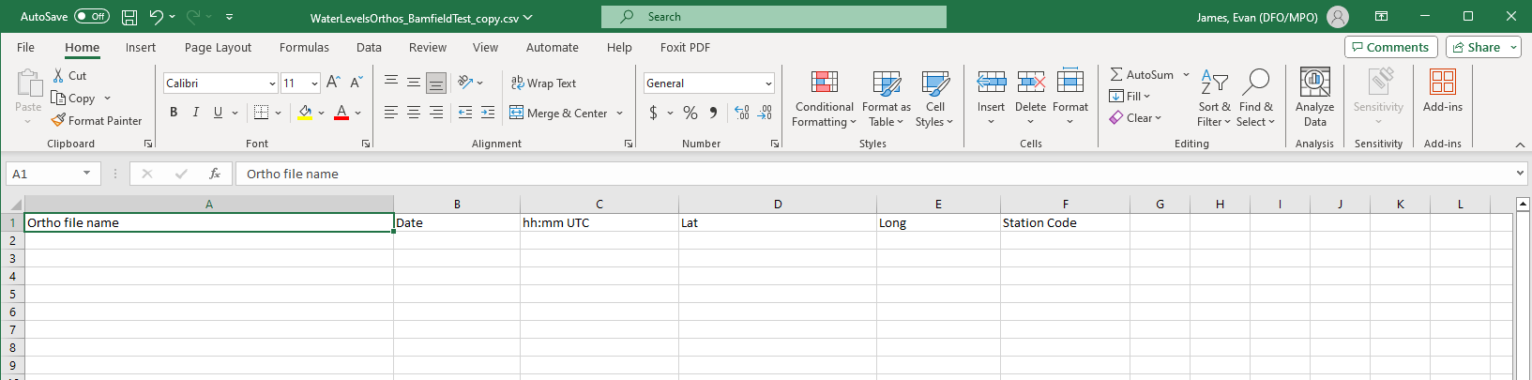Open the csv in an editor (Excel, Google Sheets, etc.) and format it exactly as follows:

* **Ensure that all the headers are in the correct cells and that the spelling and capitalization matches the image exactly.**

1. As for the entries under the headings:
   * “Ortho file name” should contain the file name of the orthophoto.
     + This will be used to display a new file name with the water level included. However, in version 0.1 this actualizes in simply including the new name in the csv file, not changing the file name itself. If that is of no importance you may leave it blank for simplicity (in this case the ortho name will appear as “nan”).
   * “Date” should contain the date in mm/dd/yyyy or yyyy/mm/dd format
   * “hh:mm UTC” should contain the UTC timestamp in hh:mm format. Do not include seconds.
   * “Lat” should contain the latitudinal coordinate.
     + Valid formats are:
       - deg-min-sec and a cardinal direction (ex: 45-29-29.8S)
       - decimal degree and a cardinal direction (ex: 45.8899S)
       - positive/negative decimal degree (ex: -45.8899)
   * “Lon” should contain the longitudinal coordinate with the same formatting specifications as latitude.
   * “Station Code” is an optional field. If you know the station that you would like data from you may enter its 5-digit code and it will provide only the data from that station. If you enter a station code you may also skip entering a latitude, longitude if you would like.

* 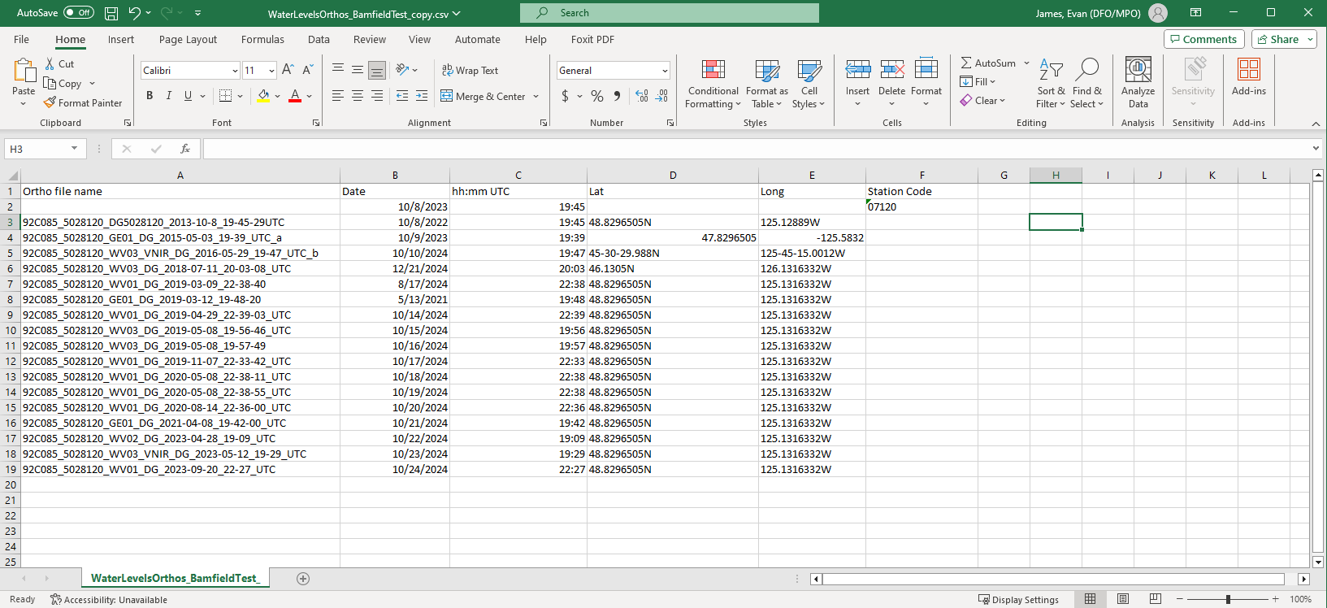Your completed csv file should look similar to the following:

## Part two: Using the program

1. 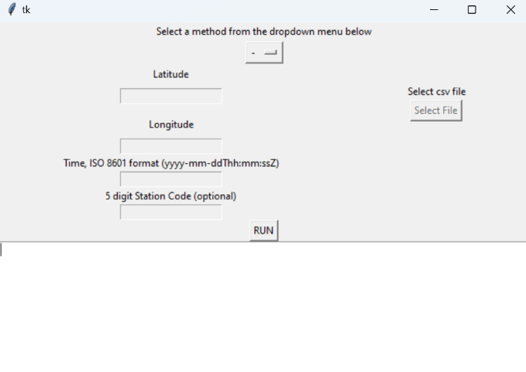Open the program executable. After a small wait you will see the following user interface:
2. You may either choose to use a CSV file (the process for creating the csv file is outlined in part one above) or single inputs from the dropdown menu at the top of the window.

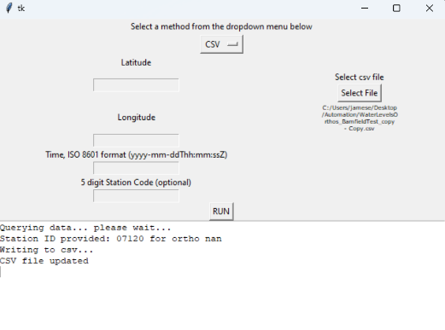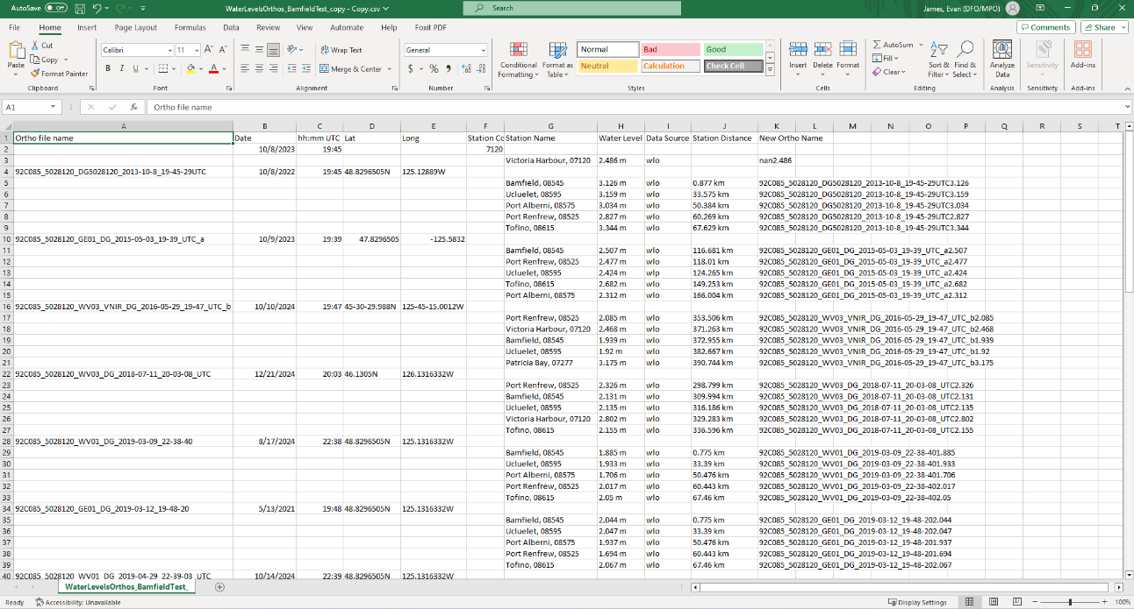For the CSV option, select “CSV” in the dropdown menu. Next, click “Select File” then locate and open your csv file in the popup window. Then simply click “RUN” and after a short wait all the information will be input directly into the csv you provided. After expanding the columns, your csv file and UI should look similar to this:

1. For the single input option, select “Single Input” from the drop down menu and then:

* Valid formats for latitude longitude coordinates are:
  + deg-min-sec and a cardinal direction (ex: 45-29-29.8S)
  + decimal degree and a cardinal direction (ex: 45.8899S)
  + positive/negative decimal degree (ex: -45.8899)
  + Timestamp should follow ISO 8601 format as is displayed on the UI.
  + The “T” and “Z” are simply the uppercase characters T and Z and must be included.
  + Ex: 2024-09-21T13:00:00Z = Sept 21, 2024 at 1 pm
* The 5 digit code is optional and will provide the data from the station provided at the time provided. You may also skip the coordinates if you enter a station code.

After clicking “RUN”:

* 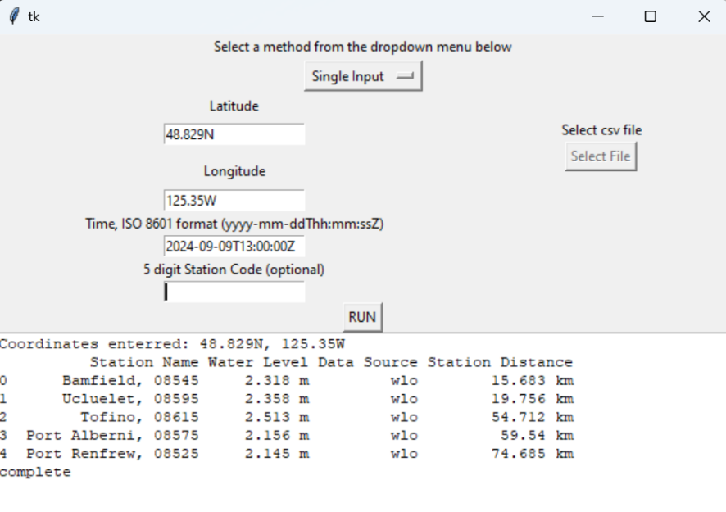If no station code is provided the UI will display the 5 closest stations name, water level, data source and distance.
* 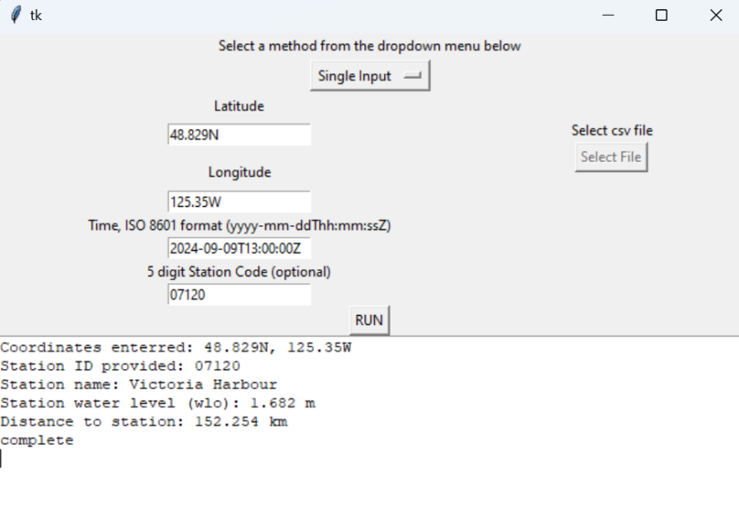If a station code is provided the UI will display only the data from the provided station.